**SecuraAI: Transforming Phishing Detection with Machine Learning**

**Samriddhi Sharma**

**Date: 1.06.2024**

**Task -0**

**ABSTRACT**

Phishing attacks are a persistent and escalating threat in the digital landscape, causing substantial financial and data losses for individuals and organizations. Traditional security measures often fall short, relying on reactive strategies that detect threats post-incident. CyberGuard introduces an innovative, AI-driven solution for predicting and preventing phishing attacks in real-time. Leveraging advanced machine learning algorithms, CyberGuard offers a highly accurate, proactive defense mechanism that seamlessly integrates with existing cybersecurity infrastructures.

This business model outlines the strategic framework for deploying CyberGuard as a market-ready product, detailing its value proposition, target market, revenue streams, and operational plan. By focusing on proactive protection, ease of integration, and continuous improvement through machine learning, CyberGuard aims to provide a robust solution to mitigate phishing risks. The model also addresses financial projections, marketing strategies, and risk management, ensuring a comprehensive approach to transforming this cutting-edge technology into a sustainable and impactful business

1. **PROBLEM STATEMENT**

Phishing attacks have become a ubiquitous and highly sophisticated threat in the digital world, targeting both individuals and organizations. These attacks deceive users into providing sensitive information or installing malware, leading to severe financial losses, data breaches, and compromised personal and corporate security. Despite the deployment of various security measures, phishing incidents continue to escalate in frequency and complexity, outpacing the capabilities of traditional detection and prevention systems.

Current solutions are predominantly reactive, identifying and mitigating threats only after they have already caused damage. This reactive approach leaves significant gaps in protection, as it fails to anticipate and prevent new and evolving phishing techniques. As a result, there is a critical need for an advanced, proactive solution that can predict and prevent phishing attacks in real-time, providing robust and continuous protection to safeguard digital assets and maintain user trust.

1. **Market/Customer Need Assessment**

Market Overview : Phishing attacks are a growing threat, necessitating robust cybersecurity solutions. The demand for anti-phishing tools is rising due to increased digital activities and sophisticated attack methods.

The market for phishing prevention solutions is expanding rapidly due to the increasing frequency and sophistication of phishing attacks. Small to medium-sized enterprises (SMEs) often lack the resources for in-house cybersecurity measures and need cost-effective, easy-to-implement solutions. Large enterprises, particularly in finance, healthcare, e-commerce, and education, require comprehensive protection due to the high volume of sensitive data they handle. Security service providers seek advanced tools to enhance their offerings, while individual high-risk users such as executives and professionals need robust personal protection.

Key customer pain points include the complexity of evolving phishing tactics, significant financial and data loss risks, inadequate existing solutions that are often reactive rather than proactive, integration challenges with current systems, and limited cybersecurity resources, especially in SMEs. Customers need a solution that offers proactive real-time threat detection, comprehensive multi-channel coverage, ease of integration, scalability to grow with their business, a user-friendly interface, regulatory compliance, and cost-effectiveness.

Market demand indicators show a rising number of phishing incidents, increasing regulatory pressure for stricter data protection, greater reliance on digital platforms due to digital transformation, and an expanding cybersecurity market indicating robust demand. The competitive landscape includes traditional cybersecurity providers and niche anti-phishing vendors. CyberGuard stands out with its advanced AI and machine learning for high accuracy and real-time detection, ease of use and integration, comprehensive multi-channel protection, and continuous updates to counter emerging threats. This positions CyberGuard to meet the clear market need for proactive phishing prevention, offering significant value through its advanced, scalable, and user-friendly solution, and capturing substantial market share in the growing cybersecurity sector.

* 1. **Target Market Segments**

Small to Medium-Sized Enterprises (SMEs): Need cost-effective, easy-to-implement solutions.

Large Enterprises: Especially in finance, healthcare, e-commerce, and education sectors, require comprehensive protection.

Security Service Providers: Seek to enhance their offerings with advanced anti-phishing tools.

Individual High-Risk Users: Executives, professionals, and frequent online shoppers need personal protection.

* 1. Customer Pain Points

Complexity of Phishing Attacks: Difficult to keep up with evolving threats.

Risk of Financial and Data Loss: Potential for significant damages.

Inadequate Existing Solutions: Many are reactive, not proactive.

Integration Challenges: Difficulty in merging new solutions with current systems.

Resource Constraints: Limited expertise and resources, especially in SMEs.

* 1. Customer Needs

Proactive Threat Detection: Real-time prevention.

Comprehensive Coverage: Protection across emails, websites, and social media.

**TARGET SPECIFICATIONS**

This model is designed to proactively detect and prevent phishing attacks in real-time using advanced AI and machine learning, with an accuracy rate exceeding 95% and minimal false positives. It offers comprehensive multi-channel coverage, protecting emails, web traffic, social media, and messaging platforms, providing detailed reports on threats detected across each channel.

The solution seamlessly integrates with existing IT and cybersecurity infrastructures, supporting popular email clients, web browsers, and cybersecurity platforms through APIs and plugins, ensuring an easy setup process. It is scalable to accommodate the needs of small businesses to large enterprises, handling increasing data volumes and user numbers without performance degradation.

It features an intuitive user interface, providing clear visualizations of threats, easy navigation, and actionable alerts, achieving high user satisfaction ratings. It ensures regulatory compliance with data protection standards like GDPR, HIPAA, and PCI-DSS through data encryption, access controls, and audit trails, with relevant certifications and documentation.

Cost-effectiveness is maintained through competitive pricing models, offering tiered plans that scale with business size, justifying costs through reduced phishing-related losses. The solution continuously learns and adapts to new phishing tactics, updating detection algorithms automatically, improving detection rates and reducing false positives over time.

Comprehensive reporting and analytics capabilities provide real-time dashboards, weekly and monthly reports, and in-depth threat analysis, including metrics on detected threats and targeted channels. CyberGuard also supports collaborative defense by facilitating anonymized data sharing and joining threat intelligence networks, enhancing collective defense against phishing attacks.

CODE IMPLEMENTATION

Github link: https://github.com/samriddh-i/inventory-management

* Visual ispection of data:

df = pd.read_csv("DataCoSupplyChainDataset.csv", encoding="ISO-8859-1")

df.head(2)

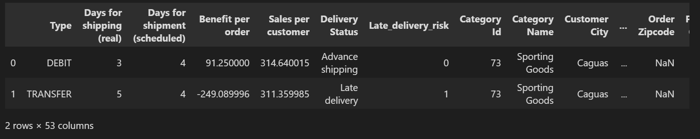

*Data Preprocessing

we will focus on historical sales data, and product attributes like; stock level, and product category, we will also analyze the impact of other variables that contribute to demand patterns including geographic factors, customer segments and lead time.

1. Preprocessing Tasks
2. Drop irrelevant columns
3. Drop rows with missing values
4. Create new features
5. Convert categorical features to numerical features

Based on the above, we will drop the majority of the columns that are not relevant for forecasting the demand and extract new features from the existing columns

* Create New Features

The dataset contains a shipping date column which is a DateTime object from which we can extract Month, Year, Day and Day of Week that can be useful in our analysis.

Month - to capture the months per sale.

Year - to capture the year per sales.

Day - to capture the day per sales.

Day of Week - to capture the day of the week per sales.

we need to also create a new Lead Time column which is the difference between the Days for shipment (scheduled) and the Days for shipping (real). This will help us understand the impact of lead time on demand.

*Data Encoding

The nature of categorical data makes it unsuitable for future analysis. For instance, machine learning models can’t work with categorical values for customer origins like UK, USA, France, etc. We will convert these categorical values to numerical values using the LabelEncoder from the sklearn library.

I will also perform a [one-hot encoding](https://www.geeksforgeeks.org/ml-one-hot-encoding-of-datasets-in-python/) technique on categorical features for future machine learning modeling tasks.

I wrote a prepare_data() function that returns two preprocessed dataframes: one that is encoded using a label encoder function and the other encoded using one hot encoding technique.

*Visualizing the Distribution of the Dataset

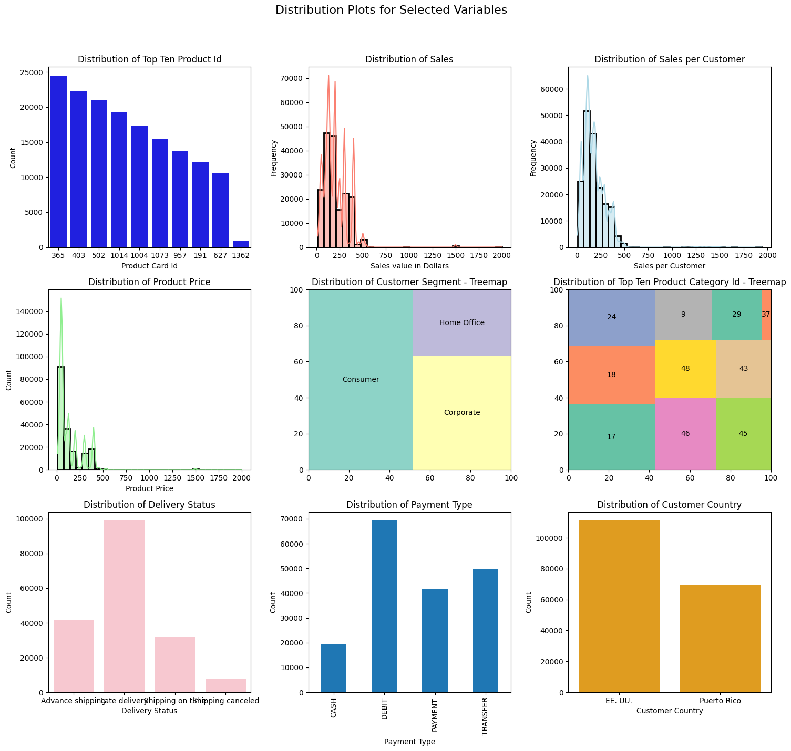

Exploratory Time Series Visualisation

To understand the demand patterns of the top-selling product, let’s create a time series heatmap to visualize the demand patterns of the top-selling product over time.

Time Series HeatMap of The Demand

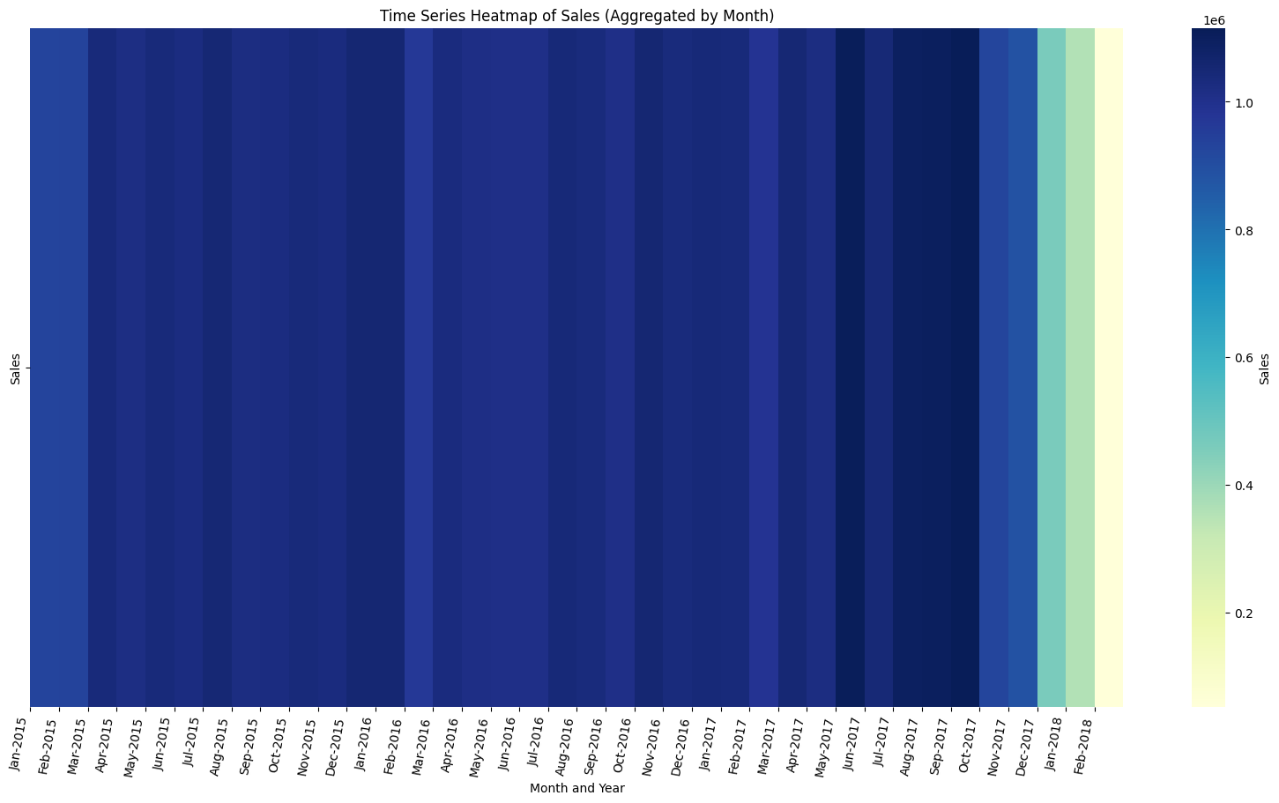

judging from consistency in the shades of the heatmap, we can see that the demand for the top-selling product is fairly stable over time. However, it is interesting to note that the number of sales recorded for the first quarters of 2015, 2016 and 2017 remained consistent however in 2018 the number of sales recorded in the first quarter dipped significantly. This is an interesting insight that we can explore further.

Next, Let’s use the Prophet library to model the demand for the top-selling product. This will help us understand the cyclical patterns in the demand for the top-selling product.

Forecasting Demand with Prophet

Prophet is a forecasting tool developed by Facebook. It is designed for analyzing time series data that display patterns on different time scales such as yearly, weekly, and daily. It also has advanced capabilities for modeling the effects of holidays on a time series and implementing custom seasonalities.

CONCLUSION

The SupplyChain Optimizer with AI-driven inventory and demand management is a transformative solution for businesses seeking to optimize their supply chain operations. By leveraging advanced machine learning algorithms and real-time data analytics, this platform provides accurate demand forecasting, automated replenishment, and enhanced inventory tracking. The integration of revenue streams such as subscription fees, setup fees, consulting fees, and data analytics services ensures a sustainable and scalable business model.

With the added capabilities of machine modeling for data collection, model training, and validation, the SupplyChain Optimizer offers a comprehensive approach to inventory management. This results in increased operational efficiency, cost savings, and improved customer satisfaction. Businesses can make data-driven decisions, reduce stockouts and overstock situations, and maintain optimal inventory levels, ultimately leading to a more agile and responsive supply chain.

In summary, the SupplyChain Optimizer empowers businesses with the tools and insights needed to stay competitive in today's dynamic market, driving both efficiency and profitability in their supply chain processes.